Third Grade Fridge Facts
Week of: Dec. 14 - 18, 2015

Help needed:

Please ask your student if he or she in need of any supplies for school. We have noticed many students need pencils and the supply of tissues in the classrooms has gotten low.

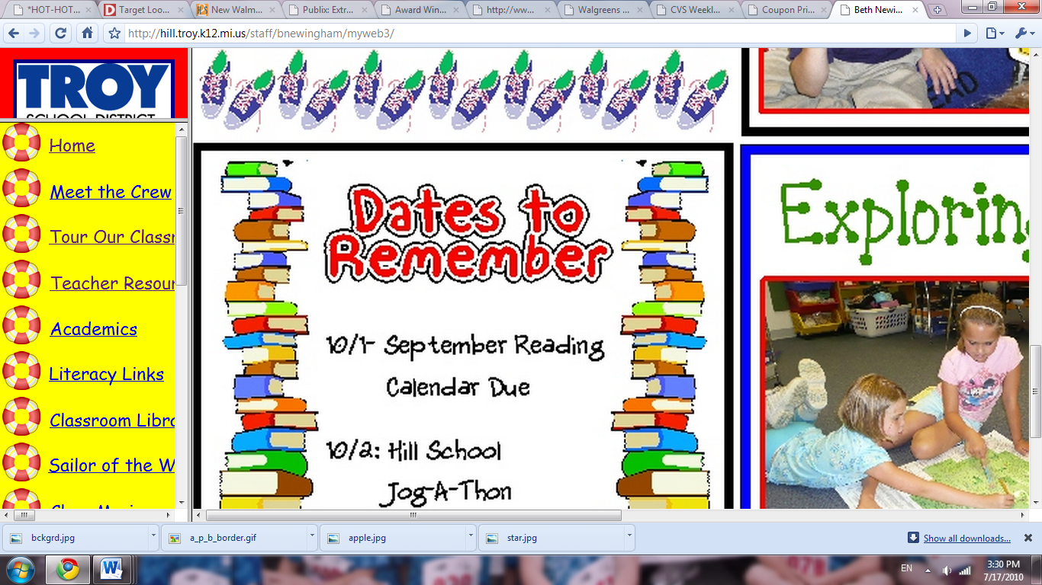

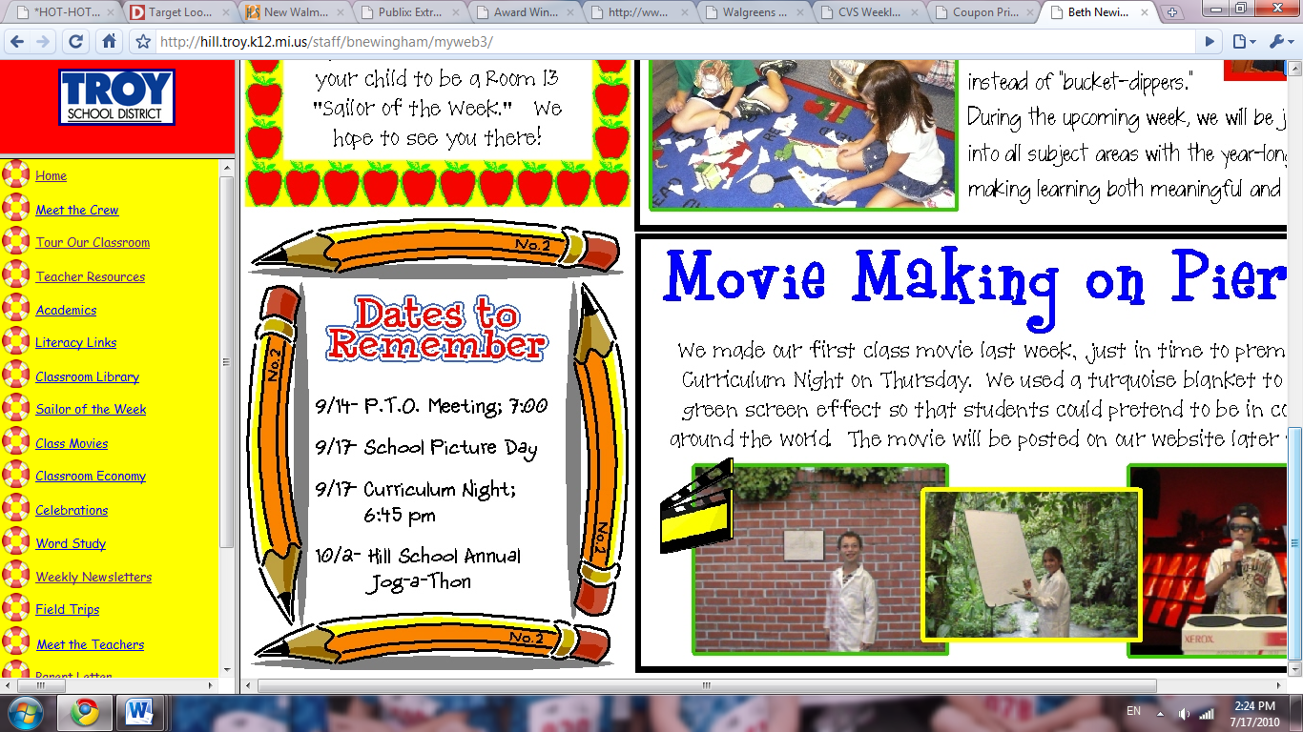

December 14-18 Holiday Shop
December 17 – PJ and Grinch Day
December 18 – holiday parties
December 21 – January 4 - Christmas break

This Week's Spelling Words

Cent, price, trace, bicycle, twice, campus, scrape, crush, cramp, cancel
RED WORDS: measure, remember, early , waves
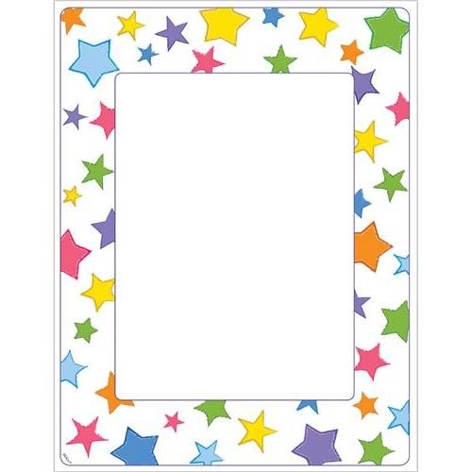
Homework
All Spelling Homework (3 spelling squares) is Due on Friday.

Math Homework is due the next day after it is given! (Due Wed. and Friday)

Complete the comprehension on the back by Friday.

Students are expected to
read 100 minutes each week. Please sign that your child has read 100 minutes this week.
______________________

Peek at our Week

Reading:
Literary elements
Language Arts:
Narrative writing
Math:
Division and word problems
S.S./Sci.:
Magnest
Spelling:
Hard/soft c

